**UNIVERSITY OF INFORMATION TECHNOLOGY**



**PROJECT:**

**APPLE STORE**

Lecturer: Nguyễn Thanh Bình

Group: 6

Members: Lê Văn Phúc – 19522033

Nguyễn Thanh Trúc – 19522417

Bùi Thị Thúy Ngọc – 19521904

Phạm Minh Quang – 19522099

1. **Introduction to the topic**
2. **Overview of the topic**
3. Software implementation tools:

* Tools:
* Vscode: is a lightweight but powerful source code editor which runs on your desktop and is available for Windows, macOS and Linux. It comes with built-in support for JavaScript, TypeScript and Node.js and has a rich ecosystem of extensions for other languages and runtimes (such as C++, C#, Java, Python, PHP, Go, .NET). We use it to execute BE and Fe code.
* SQL Workbend: provides data modeling, SQL development, and comprehensive administration tools for server configuration, user administration, backup, and much more
* My SQL: provides cost-effective, high-performance, scalable database applications.
* Posman: to be able to interact with the API. API stands for Application Programming Interface - application programming interface. The API is responsible for making connections between different applications. And Postman will be responsible for making it easier for users to manipulate the API.

1. Functions:

curd (product catalog, product group, product details, purchase order)

1. User Objects:

The website is applied for 2 objects: admin and customer:

* Admin: add, delete, edit product information, check orders, login, logout, register
* Customers: view products, add products to cart, place an order.

1. Links:

* Link web: <https://ngochai.shop/>
* Link API doc: <https://www.postman.com/interstellar-resonance-778535/workspace/api-apple-store?fbclid=IwAR08wBgLrOxkR4TqVcLUxvTChyQ2WpStzBfYH-Mz2-Y_yzWFayf2zGfdNvw>

1. **The reason for making the topic**

In the 4.0 era, the Online market has become a fertile and potential business market, not inferior to the Offline market. Therefore, creating a website for your phone store is also how you choose "location", "set up space" and launch to customers everywhere in the market not only offline but also online. In addition, one of the important reasons that our team conducts this study is:

* Customers will know you more and more widely

If before, people used to pass the address to each other when recommending something, now people change the habit with a link. Your customers sometimes don't have to go out, everything can be bought with just one easy click. Therefore, if you still do not quickly design your own website to sell phones, you inadvertently lose the opportunity to reach your potential customers.

* Designing a mobile phone sales website will help you sell more goods

At the present time, buying and paying online for items of medium to high value is extremely familiar to the majority of consumers. Therefore, owning a website to sell phones is also the time when your online "store" is ready to receive huge and unexpected orders.

* Cost savings for beginners

If you are an individual just starting out with a small shop with a moderate cost, an online business with a website selling phones is a very right investment. You should know that an effective phone sales website will help you reach customers quickly, reduce marketing costs, and fixed costs such as premises, labor, electricity - water, property depreciation...

* Safe business against unexpected risks

The consequences of the world's largest pandemic - Covid 19 have left us with countless great losses in human and property. Almost all industries are temporarily shelved, frozen in the siege of isolation and distance. However, the e-commerce industry is still a strong growing industry in the past period. This is also a new way out for businesses in the face of unpredictable external harm like Covid 19.

* Create a competitive advantage over competitors

You and your competitor trade in the same product, at the same price. You are even more confident about your product. However, the phone store is completely absent from all search results, you do not have any website selling phones or website introducing products. While your opponent only needs to search to call the name, this means that you have slowed down and given the "golden" opportunity to your opponent.

* Increase brand reputation and instill trust in customers

It is not an exaggeration to think that the website is the very important online "representative face" of your brand, your phone shop. Design a website to sell phones carefully, seriously and thoroughly

1. **Objectives of the topic**

Objective of the system is to cover all events that are related to Apple store. Events, which are aimed to cover in this system are: admin can login, logout, register in the system, manage product catalog, product group, product details, purchase order. The bill history can be retrieved promptly. And reports will be generated based on different criteria’s. For customers, they can easily view the product, add products to cart and place an order.

1. **Feature Diagram**

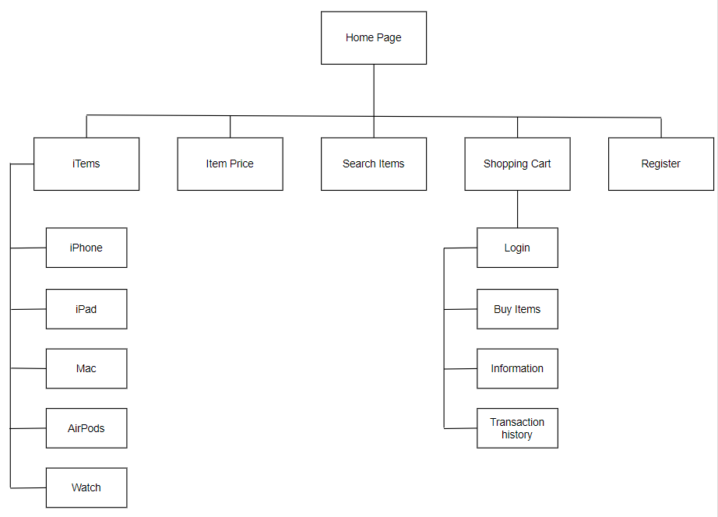

1. **System Architecture Diagram**

* System Architecture Diagram

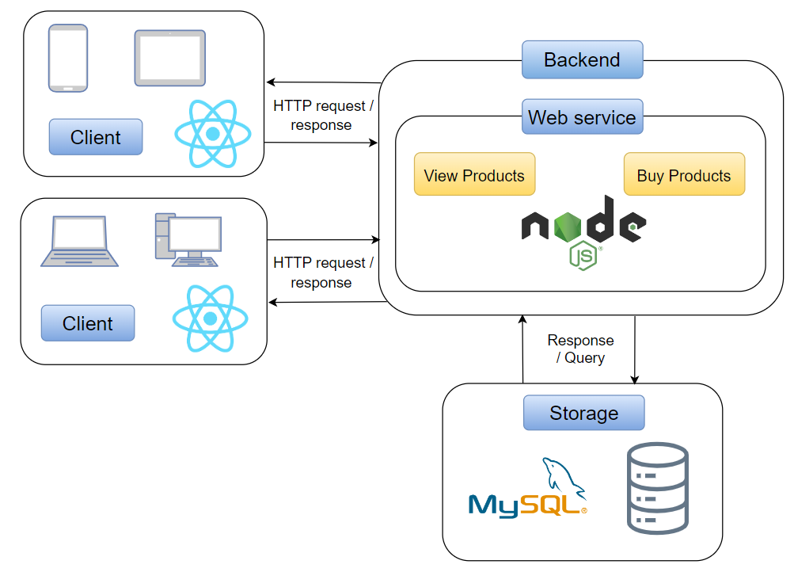

* Website Architecture Diagram

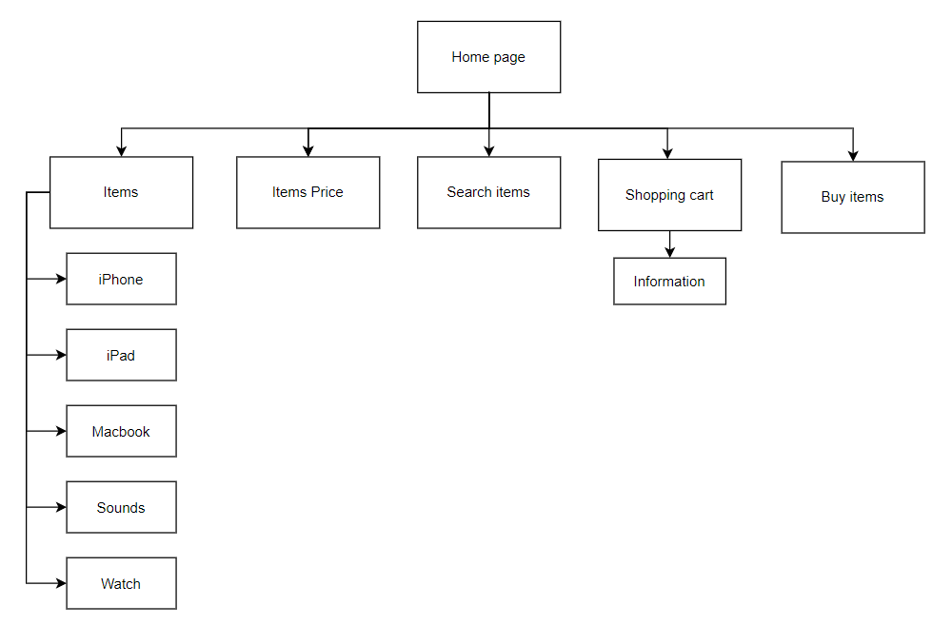

* Website Functional Architecture Diagram

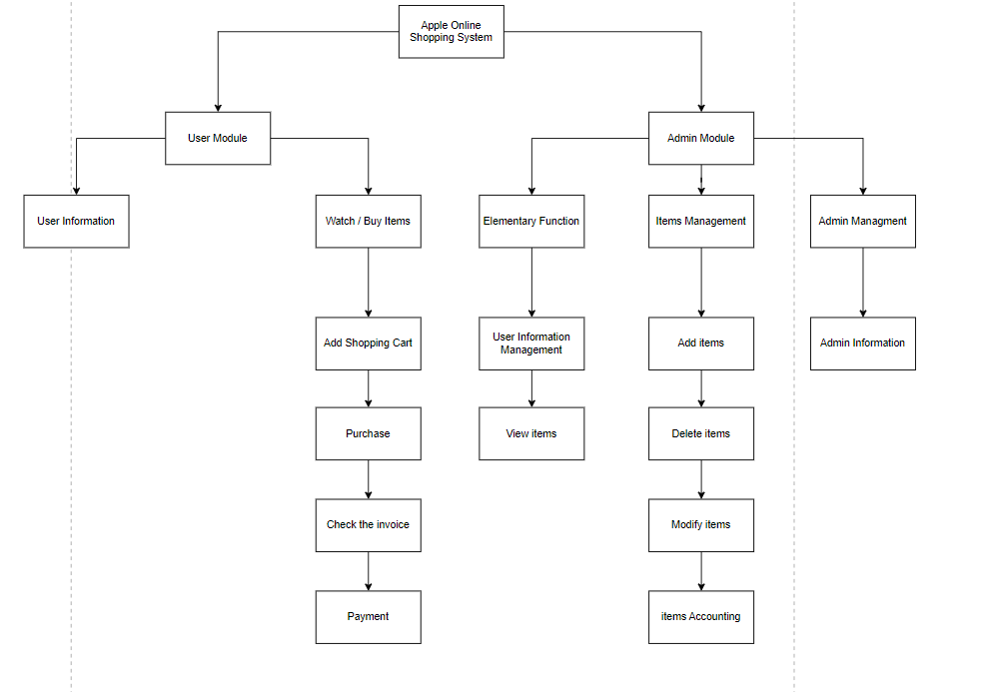

1. **UseCase Diagram**

* Customer:

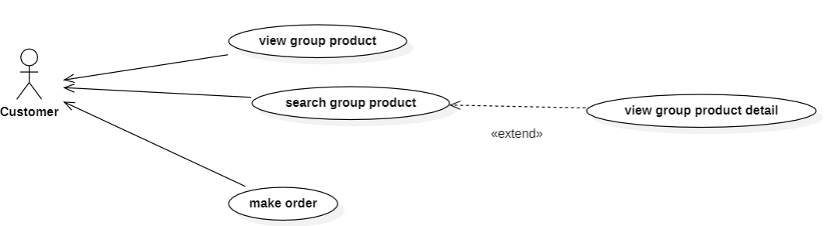

* Admin:

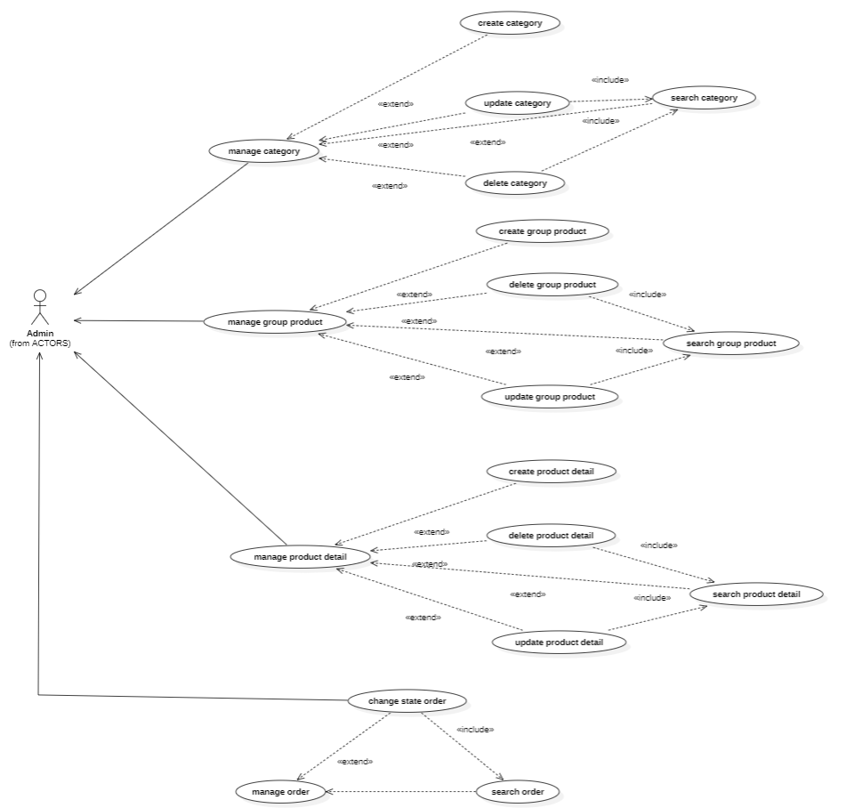

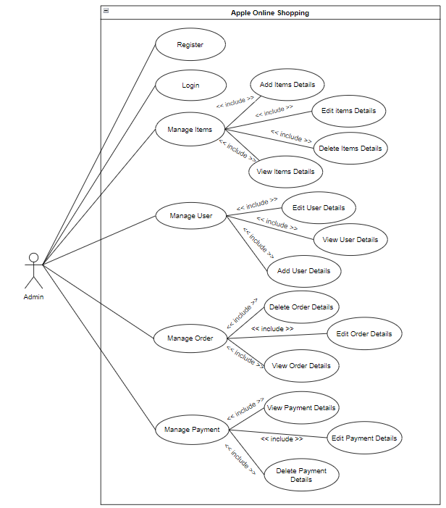

1. **Database**

* ERD:

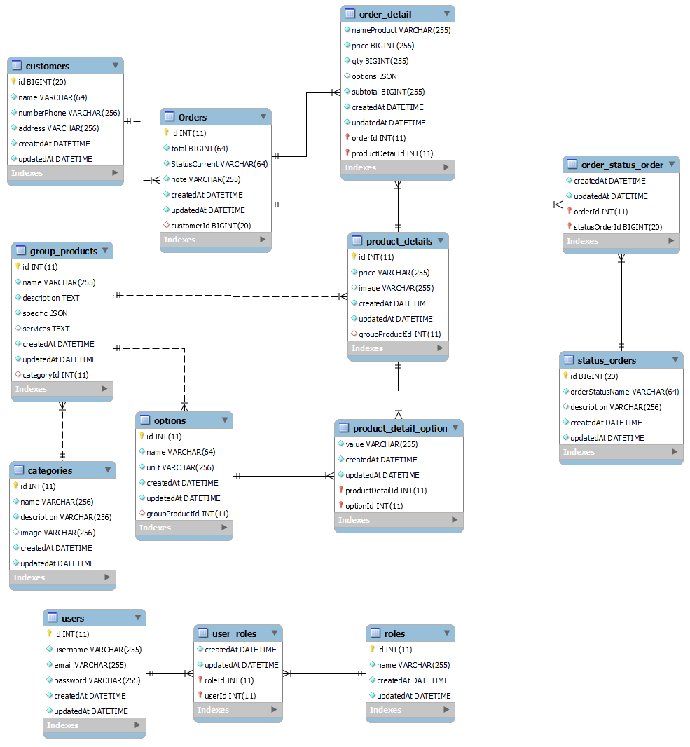

1. **Demo**
2. **References**

[**https://shopdunk.com/**](https://shopdunk.com/)

[**https://www.youtube.com/playlist?list=PLJo1W2q6iqxnT0BTF5NKBu9vfdAb4Jrkz**](https://www.youtube.com/playlist?list=PLJo1W2q6iqxnT0BTF5NKBu9vfdAb4Jrkz)

[**https://github.com/bezkoder/node-js-express-logi**](https://github.com/bezkoder/node-js-express-logi) **example?fbclid=IwAR0w-PJF3VQcJqFZ3AidLlSWjpXxob6GrGGD5YBymCdouItDE6eBNzsYUVo**

**https://github.com/nishant-666/Dynamic-Forms?fbclid=IwAR3_0sJIWfFTEWQtj1e8rKnhhA-lF6Di47eZTTFxYi4wBMxvTI01YXrA9DE**